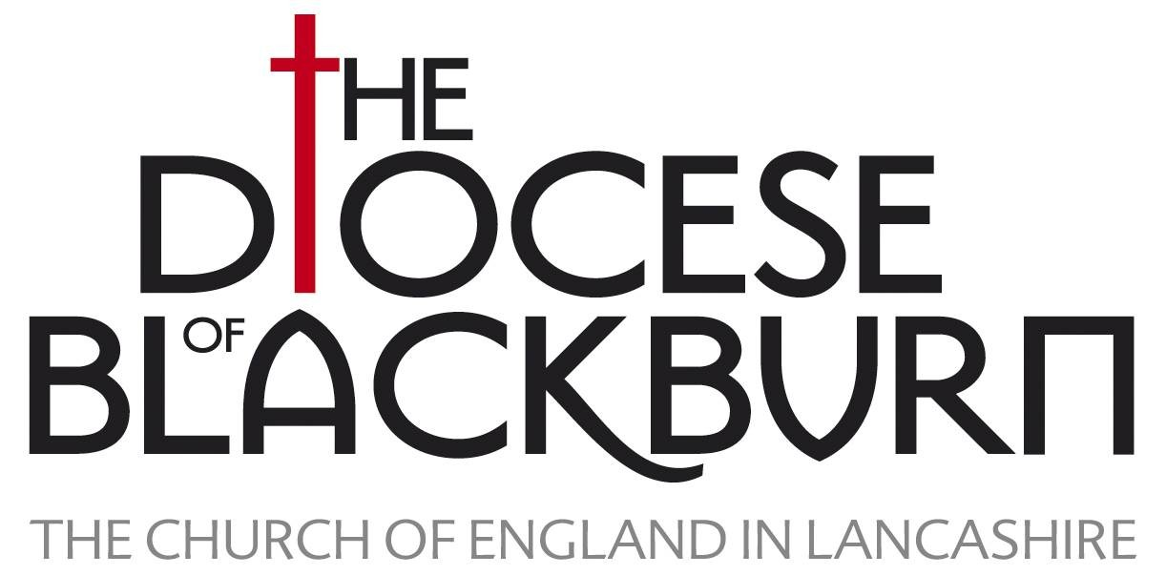


GOOD COMMEMORATIVE TREE PLANTING

OR

THE RIGHT TREE. RIGHT PLACE. RIGHT WAY

Whether it be for the celebration of a local person or event or a National Celebration, the tree you plant will need to be able to stand the test of time in very real sense. In 150 years your great great great grand children could be sitting under its canopy or in 15 years you could be reminded of your ignorance by the dead tree stem still in the ground. This very brief note is to alert you to the things to watch out for and the people you can turn to for advice.

THE RIGHT TREE

An English Oak when first planted may be only 2m high and have a branch spread of 1m but after 200 years may be 20m high and have a canopy radius of 10m and weigh more than 10 tons. A birch when planted may be similarly small when planted but after 50 years may have a height of 20m and a canopy spread of 5m. The oak will be getting old at 500 years while the birch will be felled at 130 years. Is the commemoration for a national event that will have significance over the centuries or a local event of significance for few generations?

- The form, shape, colour and seasonal effects of different species vary and this needs to be taken account of in your image of the tree in future years in the context of the buildings and the other trees nearby in 50 to 100 years time.

- The quality of young trees vary enormously. The tree donated from somebodies back garden will not have been formatively pruned and the roots will not have been carefully developed under nursery conditions. A cheap tree will save you cash but may cost you time effort and embarrassment in the future when it fails to perform. Go to an expert supplier and spend money wisely.

- The last 100 years have shown us the benefits of Avenues and tree groups but trees of the same species will all suffer from the same diseases at the same time. Elm and horse Chestnut are good examples of trees which have suffered from being planted as monocultures in past years. Sensible variety in planting has great advantages over time.

- Different tree species prefer different soil types and climatic conditions. The tree planted in the wrong place will struggle for years so a careful match of location to species is important. A look around your local area will tell you which species thrive. This will help you to work with nature and not against nature.

THE RIGHT PLACE

The average person lives for 80 years while the average tree will be mature and still growing at 200 years. When thinking about place we need to think in tree time not people time. Our judgement about where to plant is crucial.

- The church and other preserved buildings will be there in 100 years. A mature ash or oak will need a circle diameter of 20m so that space needs to be allocated within the planting plan.

- Tree Roots will interfere with grave stones paths, walls and buildings. Root damage to a church wall can be avoided if a distance of 3-4m is allowed so avoiding the rebuilding of a church wall or the removal of the tree at some point in the future. The depth of tree roots is seldom more than 750mm and very few trees have tap roots but the feeding root range of a poplar or willow can be more than 30m.

- The trees roots even though invisible after planting are as important as the canopy. Planting in a gas line easement or near to an old foul drain line which needs replacing is not a wise decision.

- Trees need light and over time will fight for dominance over other trees by competing for light. If trees are planted too close together they will suppress their neighbour and one tree will win over another. When small and first planted a small group of trees may look fine but over time the need for more planting space will show itself.

THE RIGHT WAY

Anyone can plant a tree but to do it well requires planning materials and muscle

- Is the ground free draining…should drainage be installed before planting?

- Should the tree be ground guyed or stake supported and for how long?

- Is the existing top soil OK?

- Install a watering system and dip stick water level check before you plant

- Should the tree planting surface be mulched after planting and with what?

- Who is going to water, weed and look after the tree?

- Finally….Should it have a name plate and what kind?

For more information contact the Local Authority Tree Officer or the Diocesan Tree Adviser

Ken Linford
DAC Tree Adviser

